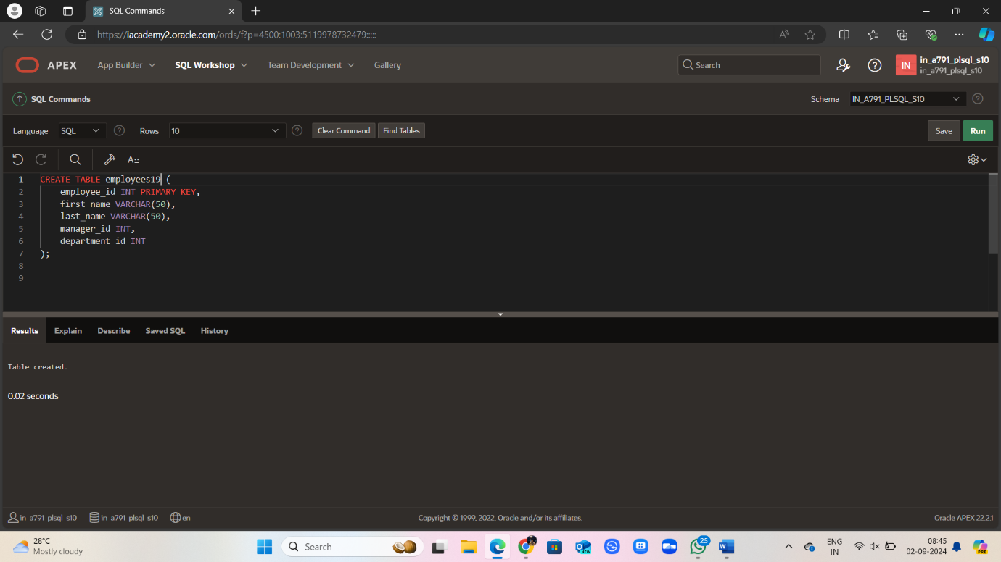

CREATE TABLE employees19 (

employee_id INT PRIMARY KEY,

first_name VARCHAR(50),

last_name VARCHAR(50),

manager_id INT,

department_id INT

);

INSERT INTO employees19 (employee_id, first_name, last_name, manager_id, department_id)

VALUES

(149, 'John', 'Doe', 101, 10),

(174, 'Jane', 'Smith', 102, 20),

(101, 'Michael', 'Johnson', NULL, 10),

(102, 'Emily', 'Davis', NULL, 20),

(150, 'David', 'Wilson', 101, 10),

SELECT employee_id, manager_id, department_id

FROM employees19

WHERE (manager_id, department_id) IN

(SELECT manager_id, department_id

FROM employees19

WHERE employee_id IN (149, 174))

AND employee_id NOT IN (149, 174);

